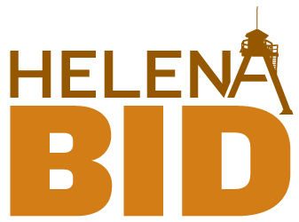

Helena Business Improvement District
Board of Trustees Meeting

Tuesday, January 12, 2016, 4:00 p.m.
HVCC Conference Room

AGENDA

Mission Statement: The Helena Business Improvement District is a leader, facilitator, provider and advocate for a planned, creative program that results in the continual improvement of property values and properties in downtown Helena.

- Welcome

- Public Comment

- Consent Agenda 5 min
  - Minutes from December 9
  - November Revised Financials
  - December Financials
  - January Program Coordinator’s Report
  - January Executive Director’s Report

- Annual Compilation

- Committee Reports 45 min

  - Executive Committee (R. Riley & A. Roy)
    - Board Retreat – January 21

  - Organization (T. Reich)
    - Work session – January 26

  - Marketing and Communications –
    - Marketing Plan Update (J. Merickel)
    - Trolley Sponsorship Request – Cool Dog Ball

  - Beautification –
    - Landscaping Update (K. Harrington & M. Roylance)

  - Economic Restructuring –
    - Downtown Master Plan Update (T. Reich)

- Downtown Helena, Inc. - Updates (D. Torgerson) 15 min

- News & Announcements 15 min

- Adjourn

ADA NOTICE
The City of Helena is committed to providing access to persons with disabilities for its meetings, in compliance with Title II of the Americans with Disabilities Act and the Montana Human Rights Act. The City will not exclude persons with disabilities from participation at its meetings or otherwise deny them the City’s services, programs, or activities. Persons with disabilities requiring accommodations to participate in the City’s meetings, services, programs, or activities should contact the City’s ADA Coordinator, Elroy Golemon, as soon as possible to allow sufficient time to arrange for the requested accommodation, at any of the following:
(406) 447- 8490 TTY Relay Service 1-800-253-4091 or 711 citycommunitydevelopment@helenamt.gov
316 North Park, Avenue, Room 440, Helena, MT 59623

Next BID Board Meeting – February 9, 2016 – 4:00pm HVCC Conference Room

