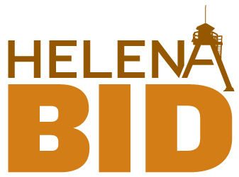

Helena Business Improvement District
Board of Trustees Meeting

Tuesday, January 10, 2017, 4:00 p.m.
Chamber of Commerce Building

AGENDA

Mission Statement: The Helena Business Improvement District is a leader, facilitator, provider and advocate for a planned, creative program that results in the continual improvement of property values and properties in downtown Helena.

- Welcome

- Public Comment

- Consent Agenda 5 min
  - Minutes from Dec 8
  - December Program Coordinator’s Report
  - ED Report for December
  - Work Plan Progress Report
  - November Financials & Notes

- Downtown Helena, Inc. - Updates (R. Ahmann) 10 min

- Committee Reports 30 min

  - Executive (R. Riley & M. Roylance)
    - Board member recruitment
    - transition update

  - Marketing and Communications (J. Merickel)

    - Website
    - Newsletter
    - Master Plan Marketing Campaign

  - Streetscape (K. Harrington & M. Roylance)

    - Flower Baskets & Spring Prep

  - Downtown Master Plan (All)

    - Public Market grant update
    - Façade Improvement Grant Update
    - Zoning Update?

  - Advocacy (Al & all)

- Old Business 20 min

  - Central School
    - Monday Event
    - Tuesday Board Meeting

- Updates 10 min

  - Recommend using interviews in Jan & Board retreat in Feb as work sessions

- News & Announcements 10 min

- Adjourn

ADA NOTICE
The City of Helena is committed to providing access to persons with disabilities for its meetings, in compliance with Title II of the Americans with Disabilities Act and the Montana Human Rights Act. The City will not exclude persons with disabilities from participation at its meetings or otherwise deny them the City’s services, programs, or activities. Persons with disabilities requiring accommodations to participate in the City’s meetings, services, programs, or activities should contact the City’s ADA Coordinator, Elroy Golemon, as soon as possible to allow sufficient time to arrange for the requested accommodation, at any of the following:
(406) 447- 8490 TTY Relay Service 1-800-253-4091 or 711 citycommunitydevelopment@helenamt.gov
316 North Park, Avenue, Room 440, Helena, MT 59623

Next BID Board Meeting – Mar 9, 2016 – 4:00 pm Valley Bank Community Room

